**Assignment -5 Named PL/SQL Block: PL/SQL Stored Procedure and Stored Function**

**Create tables and procedures: IF ELSE CONTROL**

**Prerequisite- create database**

use database dbmspracticals;

create table result(roll int,sname varchar(25) primary key, class varchar(20));

create table stud_marks(sname varchar(30), marks int,FOREIGN KEY (sname) REFERENCES result(sname));

delimiter //

create procedure procGrade(IN rno int, out grade varchar(20))

begin

declare m int;

select marks into m from stud_marks where sname = (select sname from result where roll = rno);

if m>=990 and m<=1500 then

select 'Distinction' into grade;

update result set class = 'Distinction' where roll = rno;

elseif m>=900 and m<=989 then

select 'First class ' into grade;

update result set class = 'First class' where roll = rno;

elseif m>= 825 and m<=899 then

select 'Higner Second class' into grade;

update result set class = 'Higher_second_class' where roll = rno;

else

select '---' into grade;

update result set class = '---' where roll = rno;

end if;

end

//

delimiter //

create function func_grade(rno int)

returns varchar(25)

deterministic

begin

declare grade varchar(30);

call procGrade(rno,grade);

return grade;

end //

**Insert values into table Result and stud_marks:**

insert into result values(1,'om',''),(2,'priya',''),(3,'Arav','');

insert into stud_marks values('om',1300),('priya',950),('Arav',500);

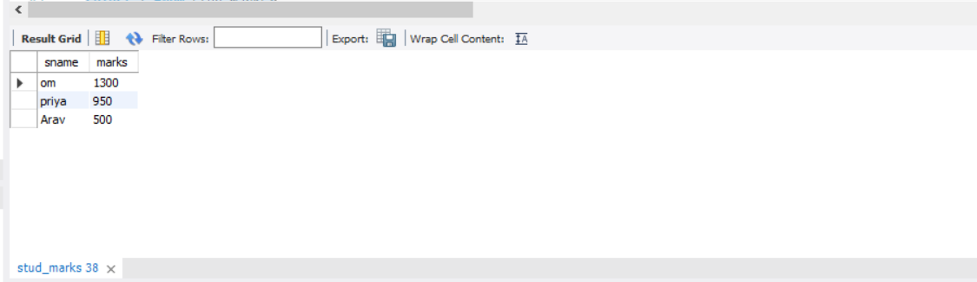

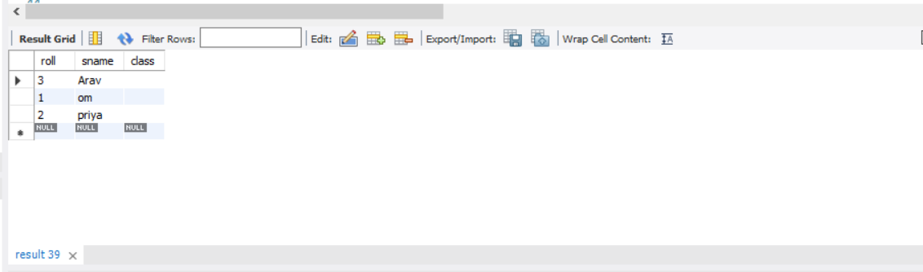

Calling function:

select func_grade(2);

**OUTPUT:**

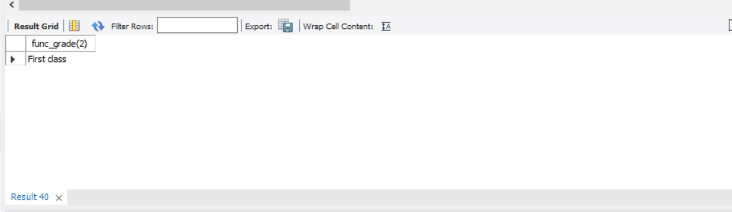

select func_grade(2);

**OUTPUT:**

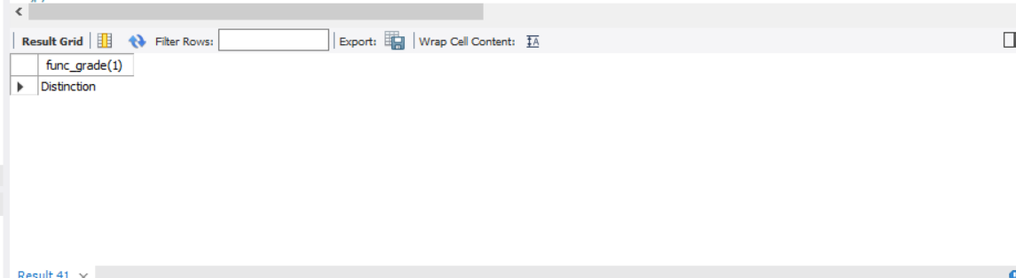

**STUD_TABLE: (after calling fun_grade())**

select * from stud;

